**Solution to Exercises for the Final Exam**

**Question 1: Rating College Football Teams**

Consider the following variation of the Rating College Football Teams example we discussed in class. Suppose the home team (column F) and the visiting team (column G) are represented by *Team Index* (as opposed to *Team Name* in the class example).

|  |
| --- |
| 100 |
| … |
|  |
| … |
|  |

What’s the formula for cell K6?

=VLOOKUP(F6,A$12:C$135,3,FALSE)-VLOOKUP(G6,A$12:C$135,3,FALSE)+B$3

**Question 2: Rating College Football Teams (continued)**

Specify solver for the Rating College Football Teams problem below:

Set Objective: F2

To: ○ Max X Min ○ Value of: _________

By Changing Variable Cells: C12:C135, B3

Subject to the Constraints:

|  |
| --- |
| B6 = B8 |

□ Make Unconstrained Variables Non-Negative

Select a Solving Method: GRG Nonlinear

Based on your rating results, list the top 3 college football teams below:

|  |  |
| --- | --- |
| Rank | Team Name |
| 1 | Alabama |
| 2 | Oregon |
| 3 | Texas A&M |

What’s the rank for Notre Dame?

8

**Question 3: Crew Scheduling**

Consider the following variation of the crew scheduling example we discussed in class:

Bob and Mary are more experienced than the other workers. Therefore the manager would like to give them higher priority during crew scheduling. In other words, when calculating the overall worker satisfaction, more weights would be assigned to the preferences of Bob and Mary. We refer to these new weights as “Priority Adjusted Weights” in the Excel file. The preferences of Bob and Mary (with priority level 2) would matter *twice as much as* the other workers (with priority level 1).

|  |
| --- |
|  |

Specify the following cells (all formulas):

|  |  |  |  |  |  |
| --- | --- | --- | --- | --- | --- |
| D7: | |  | | --- | | =B7*C7 | | E7: | |  | | --- | | =SUM(G7:G9) | |
| I26: | |  | | --- | | =SUMPRODUCT($G7:$G24,I7:I24) | | C3: | |  | | --- | | =SUMPRODUCT(D7:D24,G7:G24) | |

**Question 4: Crew Scheduling (continued)**

Specify solver for the Crew Scheduling problem below:

Set Objective: C3

To: X Max ○ Min ○ Value of: _________

By Changing Variable Cells: G7:G24

Subject to the Constraints:

|  |
| --- |
| E7:E24=F7:F24  G7:G24=binary  I26:AX26>=I28:AX28 |

□ (doesn’t matter) Make Unconstrained Variables Non-Negative

Select a Solving Method: Simplex LP

**Question 5: Roulette**

Consider the following variation of the optimal target hitting strategy in the Roulette example we discussed in class:

* Suppose you have $200 and you would like to hit the target of $300.
* Instead of betting on Red or Black, you would like to bet on the 1st Dozen (1-12).

Hint: Since the payoff is 2:1 for the dozen bets, the optimal target hitting strategy should be updated to “Bet *half* of the difference between your current winning and the target if you have enough money; otherwise, bet all you have.”

Based on the following Excel setup,

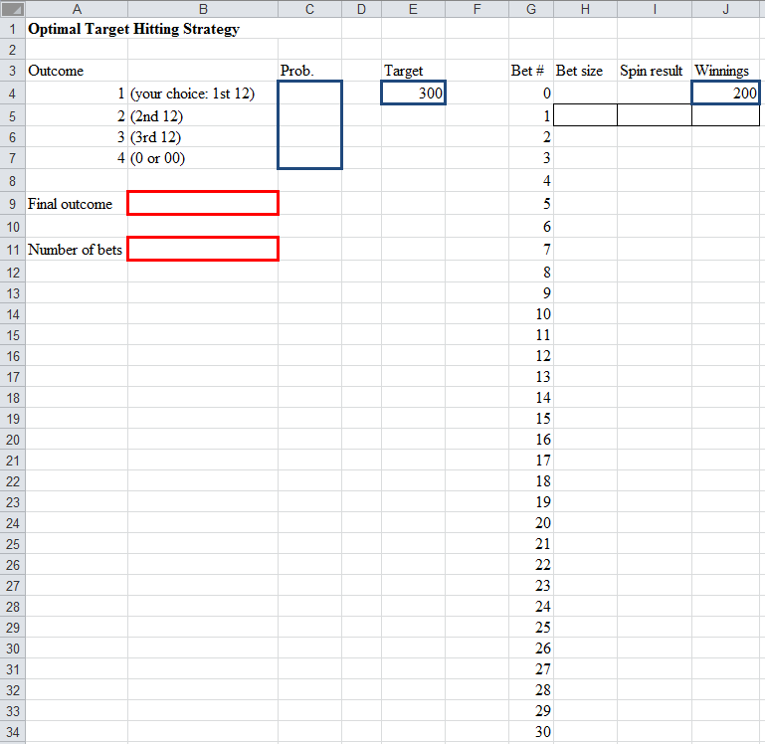

Specify the following cells (all numbers):

Cell C4: =12/38 (0.316) Cell C5: =12/38 (0.316) Cell C6: =12/38 (0.316) Cell C7: =2/38 (0.053)

**Question 6: Roulette (continued)**

Specify the following cells (all formulas):

H5: =MIN((300-J4)/2,J4)

I5: =RiskDiscrete(A$4:A$7,C$4:C$7)

J5: =IF(I5=1,J4+2*H5,J4-H5)

B9: =J34

B11: =COUNTIF(H5:H34,">0")

**Question 7: Roulette (continued)**

Run your @Risk model and answer the following questions based on the simulation results.

1. What’s the probability of hitting the target?

63.87%

1. Suppose you would stop betting either when you hit the target or you lose your $200. What’s average number of bets you could place?

2.55